SecurLOCK Equip Transaction Flow
(877) 776-3706

Integrated Payables – Zachry Industrial, Inc.

Case Study
July 2019

Steps in Transaction Flow:

Merchant to Network

Network to FIS Switch

FIS Switch to SecurLOCK Equip server

If the transaction is rejected based on the user’s card control preferences, the transaction takes the exact same path back to merchant and the transaction is declined.

If the transaction is allowed based on the user’s card control preferences, the transaction goes back to the FIS Switch.

FIS Switch to SecurLOCK (legacy Falcon). SecurLOCK Equip’s recommendation could be overridden here. If not…

SecurLOCK (legacy Falcon) to Switch.

Debit only: FIS Switch to Core. SecurLOCK Equip’s recommendation could be overridden here. If not…

Debit only: Core to FIS Switch

Credit only: SecurLOCK Equip’s recommendation could be overridden here by the Credit switch. If not…

FIS Switch to Network. SecurLOCK Equip’s recommendation could be overridden here. If not…

Network to Merchant and the transaction is approved.

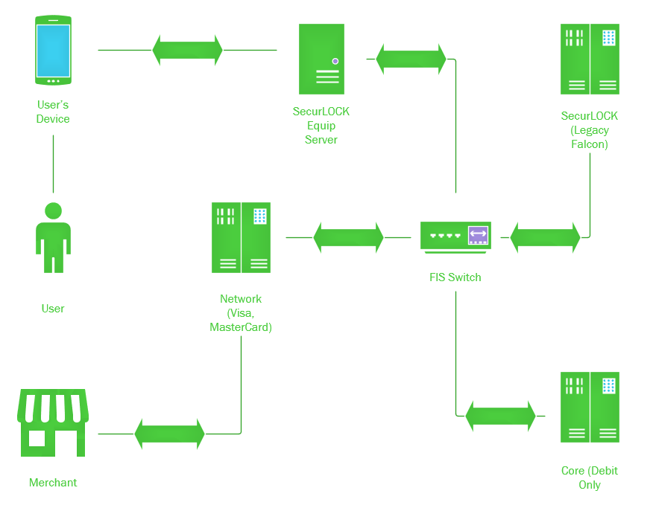
***All servers that support the product are within FIS walls and run under standard FIS security policy. The code is that of the vendor, Ondot***

